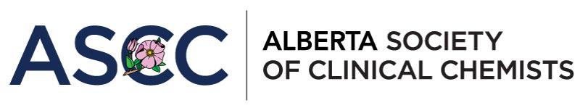

**ASCC Annual General Meeting**

**Friday, October 13, 2023**

**Primary Site (Calgary): 3535 Research Rd NW, Calgary, AB T2L 2K8, Theatre Room, Main Floor**

**Secondary Site (Edmonton): University of Alberta, ECHA, Room 1-490**

**Virtual: Zoom link will be provided to those who registered**

***"Digitization, Accessibility, and Data Science in Lab Testing”***

**Friday, October 13, 2023**

|  |  |
| --- | --- |
| 13:00 – 13:55 | **ASCC Business Meeting (ASCC Members ONLY)** |
| 13:55 – 14:00 | **Welcome and ASCC Outstanding Contribution to Clinical Chemistry Award Announcement** |
| 14:00 – 15:00 | **Keynote Speaker: Dr.** **Nitika Pai, Department of Medicine at McGill University, Centre for Outcomes Research & Evaluation, Montreal, Quebec, Canada**  2023 CSCC Travelling Lecturer, Sponsored by Biorad  ***Quoi de Neuf? Diagnostic technologies and digital solutions for transformation and impact***  At the conclusion of this session, participants will be able to:   1. Identify Novel Diagnostic (Dx) Technologies 2. Understand the evidence on connected global Dx solutions 3. Appreciate the solutions with potential for digital health transformation and their impact on patient centered outcomes |
| 15:00 – 15:10 | **Break** |
| 15:10 – 16:00 | **Dr.** **Dennis Orton, University of Calgary, Cumming School of Medicine, Alberta Precision Labs, Calgary, Alberta, Canada**  ***WorRking smart, not haRd. MoRe examples of R in the clinical lab***  At the conclusion of this session, participants will be able to:   1. Understand how R may be used to perform reproducible large-scale data analyses 2. Appreciate how using R will complement other analytics tools 3. Gain some appreciation about how the R language has evolved over time to become more user-friendly |
| 16:00 – 16:15 | **Past Trainee Presentation#1: Dr. Michael Reid, Clinical Chemist at DynaLIFE Medical Labs, Calgary, Alberta, Canada**  ***Vanishing Act: Air Exposure During Neonatal Blood Collection Significantly Reduces Total Plasma Carbon Dioxide***  At the conclusion of this session, participants will be able to:   1. Describe the components of the whole testing process that affect the stability of TCO2 and what factors result in the greatest loss of TCO2. 2. Implement strategies to reduce the loss of TCO2 in neonatal blood collections that are exposed to air |
| 16:15 – 16:30 | **Current Trainee Presentation #1: Dr. Sally Ezra, Senior Clinical Biochemistry Postdoctoral Fellow, University of Calgary and Alberta Precision Laboratories, Calgary, Alberta, Canada**  ***Development of LC-MS/MS Panel for Accurate Diagnosis of Primary Aldosteronism***  At the conclusion of this session, participants will be able to:   1. Describe the pathophysiology of Primary Aldosteronism (PA). 2. Understand the challenges associated with current immunoassays in the diagnosis PA. 3. Recognize the motivation behind developing an LC-MS/MS panel for PA diagnosis. |
| 16:30 – 16:45 | **Current Trainee Presentation #2: Dr. Fahed Elian, Junior Clinical Biochemistry Postdoctoral Fellow, University of Alberta and Alberta Precision Laboratories, Edmonton, Alberta, Canada**  ***What the HIL is happening! Evaluation of hemolysis, Icterus, and lipemia indices for specimen integrity***  At the conclusion of this session, participants will be able to:   1. Understand how hemolysis, icterus, and lipemia can interfere with clinical chemistry tests 2. Describe how HIL indices can be used to detect interferences and impact specimen handling and reporting across chemistry platforms |
| 16:45 – 17:00 | **Closing Remarks** |

**\*This event is an accredited group learning activity as defined by the CSCC/CACB professional development program**